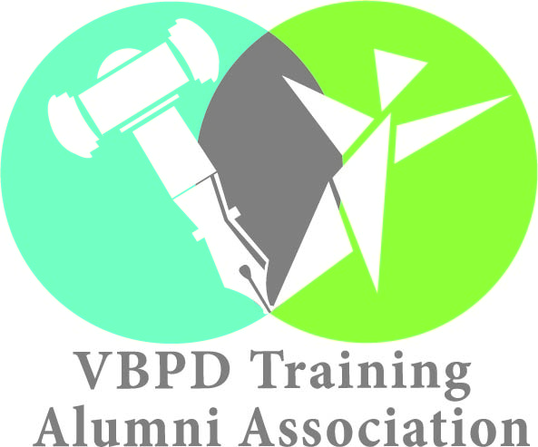

**CVA ALUMNI CHAPTER CALENDAR OF EVENTS**

**AUGUST**

**DATE**: Saturday, August 18, 2018

**TYPE OF ACTIVITY**: VAULT ADA Pride Day

**TIME:** 11:00 AM – 1:00 PM

**LOCATION:** Mobility Supercenter, 7450 Midlothian Turnpike North

Chesterfield, VA 23225, USA

*Purpose of event is for Virginians with disabilities to come together to give and receive Awareness, Knowledge, Advocacy and Support; for themselves and for others*

**OCTOBER**

**DATE**: Saturday, October 6, 2018

**TYPE OF ACTIVITY**: 12th Annual Step UP for Down Syndrome 5K & Family Festival

**TIME:** 09:00 AM – 1:00 PM

**LOCATION:** Acca Shrine Center

1712 Bellevue Ave, Richmond, VA 23227

*5K run/advocacy walk & family festival to showcase and celebrate the many abilities and accomplishments of individuals with Down syndrome*

**CVA ALUMNI CHAPTER CALENDAR OF EVENTS**

**NOVEMBER**

**DATE:** Thursday, November 8, 2018

**TYPE OF ACTIVITY:** Public Comment Henrico School Board

**TIME:** 6:30 PM

**LOCATION:** 3820 Nine Mile Road

Henrico, VA 23223

*Alumni to speak about critical issue impacting students will disabilities. School Safety or funding for students with mental illness*

**DATE**: Wednesday, November 7, 2018

**TYPE OF ACTIVITY**: Public Comment Chesterfield School Board

**TIME:** 5:30 PM

**LOCATION**: Chesterfield Career & Technical Center

13900 Hull Street Road

Richmond, VA 23112

*Alumni to speak about critical issue impacting students will disabilities in Chesterfield*

**DATE: November**

**TYPE OF ACTIVITY**: Letter Writing Campaign on Students with Mental Illness, Collaborative effort with National Alliance on Mental Illness (NAMI)

**TIME: N/A**

**LOCATION: N/A**

*Activity is to advocate for laws to protect the rights of students with mental illness and increase funding for mental health services*

**DATE:** Wednesday, November 14, 2018

**TYPE OF ACTIVITY:** Public Comment at Special Education Advisory **Council (SEAC)**

**TIME:** TBD

**LOCATION**: TBD

**DECEMBER**

**DATE:** Monday, December 3, 2018

**TYPE OF ACTIVITY:** RVA Different Abilities Day Celebration at CMoR

**TIME:** 5:30-7:30

**LOCATION:** Children's Museum Chesterfield

6629 Lake Harbour Drive

Midlothian, VA 23112

*Event is to bring awareness and celebrate persons with disabilities*

**JANUARY**

**DATE:** Tuesday, January 8, 2019

**TYPE OF ACTIVITY**: Chapter Meeting

**TIME:** 6-8PM

**LOCATION**: Pamunkey Library

Mechanicsville Branch

7461 Sherwood Crossing Place

Mechanicsville, VA 23111

Meeting Room B

804-746-9615

*Purpose of meeting is to make signs and prepare to speak with legislators on Arc DD Day*

**DATE**: Thursday, January 17, 2018

**TYPE OF ACTIVITY**: Arc of Virginia Disabilities Day (DD)

**TIME:** 9:30-AM1:00PM

**LOCATION:** General Assembly Building

201 North 9th Street

Richmond, VA 23219

*A Statewide Advocacy Event where Virginians galvanize to educate legislators & influence systems change*

**FEBRUARY**

**DATE**: Sunday, February 10, 2018

**TYPE OF ACTIVITY:** Richmond Disability Film Festival: Kesem Inclusive Theatre Project

**TIME:** 3 pm – 6 pm

**LOCATION**: Weinstein JCC

5403 Monument Ave, Richmond, VA 23226, USA

*Activity is an education initiative from the Weinstein JCC for adults ages 22 and up. Kesem will provide a comprehensive theatre education experience from process to performance. Recognizing the positive impact of arts education on the social, emotional and functional aspects of life for individuals with disabilities*

**DATE:** Tuesday, March, 5, 2019

**TYPE OF ACTIVITY:** Chapter meeting

**TIME:** 6PM – 8PM

**LOCATION:** TBD

DATE: May 2019 (Date TBD)

TYPE OF ACTIVITY: Chapter meeting

TIME: 6PM – 8PM

LOCATION: TBD

*Purpose of meeting is to recap the year and discuss future plans*

**COLLABORATIVE DISABILITY ORGANIZATIONS**

1. The Arc of Virginia

2. The Autism Society of Central Virginia

3. Down Syndrome Association of Greater Richmond

4. Cerebral Palsy of Virginia

5. Canine Companions for Independence

6. Weinstein JCC

7. VAULT

8. Project Just Like You

9. Chesterfield SEAC

10. Richmond SEAC

**AT A GLANCE CALENDAR OF EVENTS LOCATIONS**

Richmond

Mechanicsville

Charlottesville

Colonial Heights

**OVERVIEW OF CVA CHAPTER ALUMNI ADVOCACY ACTIVITIES**

Chapter Meetings

Awareness Events

Advocacy Activities

**ADVOCACY STEPS**

1. Participation/Awareness
2. Meet About Advocacy
3. Network
4. Dissemination
5. Working with Host Groups/not competing
6. Turning Information into Action
7. CVA newsletter
8. Tracking Progress
9. Segmenting/Targeting populations